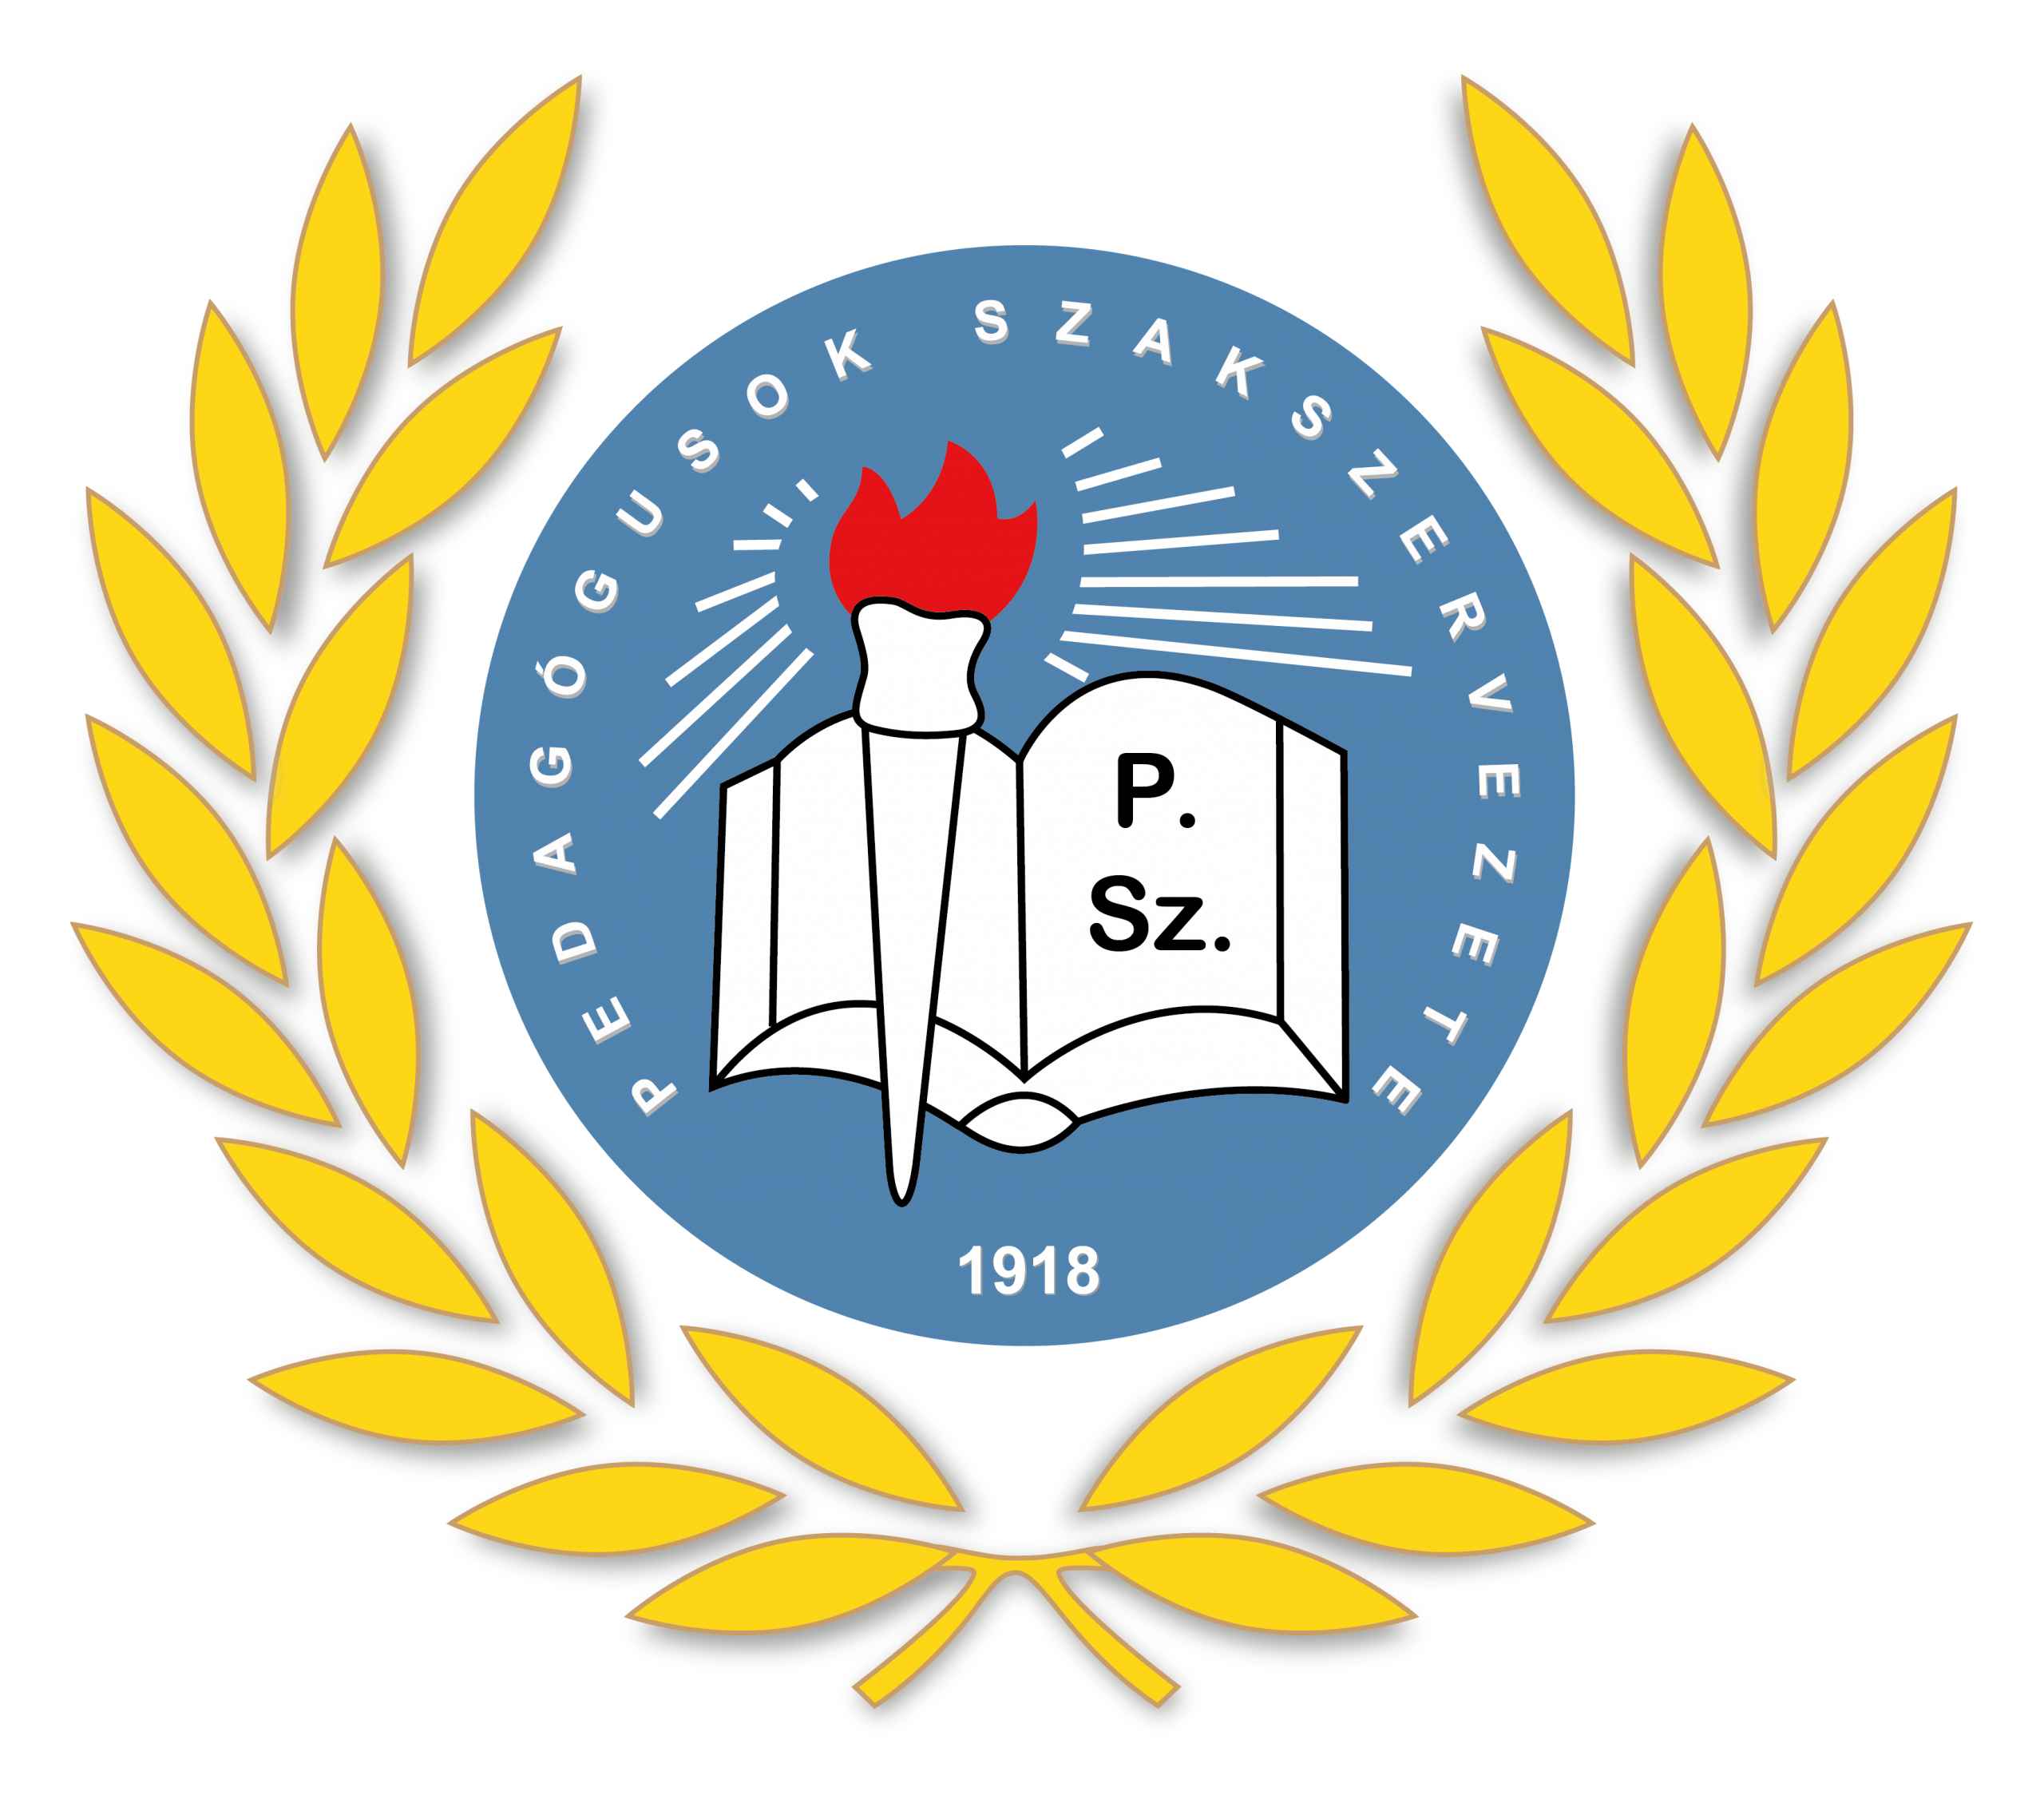

PSZ HOTEL BEACH FÖLDVÁR***


GUEST INFORMATION A-Z

Dear Guest!
We welcome you to PSZ Hotel Beach Hotel Földvár***.
We would like to inform you about the services of our hotel and help you to make your stay with us a pleasant one and to return home with friendly experiences.
Basic information
Hotel name: H-8623 Balatonföldvár, Báthory utca 40.
Phonenumber: +36-36-70/656-9005
E-mail: foglalas@pszhotelfoldvar.hu
Website: www.pszhotelfoldvar.hu
Safety requirements
Please follow the instructions for your safety during your stay:
- All hotel rooms and common areas are non-smoking. To avoid fire, please smoke only in designated areas.
- It is FORBIDDEN to store flammable or explosive materials, to operate coffee makers, water heaters, irons and other electrical appliances in the hotel room.
- Damage caused by negligence or wilful misconduct shall be compensated by the person who caused the damage to the hotel.
- In case of emergency, please inform the reception desk immediately!
- In case of fire alarm, please leave the building immediately. The escape route is posted on the room door.
- In case of fire, the use of the lift is FORBIDDEN!
- Always keep your hotel room locked and close the windows and balcony door when leaving.
- The hotel is not responsible for valuables and cash left in the hotel rooms. For the safe storage of your valuables, please use the central safe, which is free of charge!
- Please respect the peace and quiet of other guests and do not disturb it by being noisy. Between 22:00 and 08:00, please pay particular attention to ensuring the peace and quiet of others.

Important telephone numbers:
Ambulance 104
Fire brigade 105
Police 107
General emergency 112
By checking in, our guests accept the hotel's Terms and Conditions, which are available on our website at the time of booking or at the Reception upon arrival.

We wish you a pleasant stay and relaxation in the
PSZ Hotel Beach Földvár.

Car parking - Guests arriving by car can park their vehicle in the hotel's grounds, which is closed but not guarded.
Beds - Our rooms have comfortable beds with new mattresses for a peaceful stay. Our single bed is 80*200 cm, our double bed 160*200 cm.
Change of bed linen - In hotel rooms, bed linen is changed once a week on departure and once a week for stays longer than one week. On request, bed linen can be changed at other intervals for a fee. Please contact reception.
Check-in - Hotel rooms can be booked from 14.00 on the day of arrival. Early arrival is subject to availability. All guests are required to check in at the hotel and provide proof of their identity when asked by the receptionist. By checking in, our guests accept the hotel's Terms and Conditions, which are available on our website at the time of booking or at the reception desk upon arrival.
Security camera - For the safety of our guests, security cameras are installed in the common areas and corridors.
Check out - Please leave the hotel room by 10.00 on the day of departure. Late check-out is subject to availability. Please contact the reception desk.
Shoe cleaning kit - Please contact reception to request.
Luggage carriers - Free of charge. Please ask at reception.
Luggage storage - Free of charge. Please contact reception on request.
Dietary requirements - Please specify any special dietary requirements (vegetarian, food allergies, etc.) at the time of booking.
Electrical appliances - The use of electric kettles, irons, etc. in the hotel room is DANGEROUS and FORBIDDEN for fire safety reasons. If our staff are found using such appliances, they will be taken away for safekeeping and will only be returned on departure. Any damage resulting from use contrary to this prohibition will be charged to the person who caused it!
Electronic accessories - International power adapter, charging station available on request at the reception.
Umbrellas - Free of charge. Please contact reception to request.
Wake-up calls - Please contact reception.
Safekeeping - The hotel is only responsible for valuables left in the central safe. The safe is free of charge. Please contact reception on request.
Photocopying, scanning - please contact reception.
Payment methods - Payment can be made by cash, credit card (VISA, Mastercard) or SZÉP card (OTB Bank, K&H Bank, MBH Bank).
Földvár Card - All our guests are entitled to the Földvár Card, which offers a number of discounts at the local points of acceptance. Please contact reception to request one.
Smoke-free hotel - Smoking is STRICTLY FORBIDDEN in hotel rooms, balconies and common areas. Rooms and common areas are equipped with smoke detectors. Failure to comply will result in a fine and termination of service!
Cots - Limited number of cots available. Please contact reception upon request.
Child-friendly hotel - Cots, baby cots and high chairs are available at reception. For baby food heating facilities, please contact reception.
Medicines - Basic medicines (painkillers, bandages) and a thermometer are available on request.
Hairdryers - All hotel rooms are equipped with hairdryers.
Hygiene products - Shaving products, toothbrushes, toothpaste are available at the reception for a fee. Liquid soap and shower gel are available in the bathrooms free of charge.
Refrigerator - Hotel rooms are equipped with a refrigerator.
Internet - The hotel rooms and common areas are equipped with free internet (WIFI). The password required to use this service is Vendeg21.
Games and sports equipment - A limited number of games such as table football, darts, billiards, table tennis and badminton are available for hire free of charge.
Maintenance - If any of the equipment in your room is not working or needs repair, please notify reception.
Damages - Our guests are liable for damages caused to the hotel, other guests or third parties. The hotel will only be liable for large items of property and cash if they have been taken into safe custody.
Late check-out, early check-in - Both services are subject to availability. Please contact reception for details.
Excursions, activities - Please ask at reception, where printed brochures of things to do in the area are available.
Pets - Pets are not allowed.
Social media - Our hotel is on Facebook and Instagram. Please follow the pages and keep an eye on our news and promotions.
Visitors - We kindly ask our guests to welcome their visitors in the common areas of the hotel. Visitors are only allowed to enter the hotel room after checking in at the reception and are not allowed to stay after 20:00. In case of violation of this rule, the reception will charge the price according to the current price list.
Elevator - The floors can be accessed by elevator and via the staircase.
Laundry and ironing service - Please contact reception.
Sun loungers - A limited number of sun loungers are available in the garden of the hotel during the summer, free of charge.
Medical on-call - Please consult a specialist if you have a medical complaint or unexpected illness. Our reception will be happy to advise you of the nearest doctor's surgery, hospital or pharmacy. Please contact reception with your request.
Parking - Closed parking is available for guests arriving by car on the hotel premises, subject to availability.
Blankets, pillows - Blankets and pillows are available on request. Please inform the reception.
Teachers' Union discount - Members of the Teachers' Union receive a 30% discount on accommodation, breakfast and parking. The discounts are also available for immediate family members (husband, wife, children), for a maximum of 2 rooms, upon presentation of a membership card only.
Radio - You can set the radio on the in-room television. Bartók Radio, Dankó Radio, Kossuth Radio, Petőfi Radio.
Reception - Available 24 hours a day.
Breakfast - Buffet breakfast is served every day between 07:30-10:00 in the hotel restaurant. Please inform us of any special dietary requirements prior to arrival. Food and drinks should not be taken out of the restaurant.
Outdoor recreation - Outdoor recreation is available in the hotel's own garden and on the Eastern Beach, 50 metres away.
Hotel rating - Our hotel is officially rated three stars (***) by an external professional organisation.
SZÉP card - Our hotel accepts Széchenyi Pihenőkártya. Please ask at reception for more information on how to use it.
Cleaning - Rooms are cleaned daily. If you do not wish to use the daily cleaning service, please inform the reception or use the "Do not disturb" sign in the room.
Lost property - Can be picked up or dropped off at the Reception after proper identification.
Taxi, shuttle - Please ask at reception, our staff will be happy to assist you with taxi or shuttle arrangements.
Towel change - Towels in hotel rooms are changed once a week for stays longer than 7 nights or on departure. Towels can be changed at other intervals on request. Please contact reception to request this. Bathroom linen may not be taken out of the hotel.
TV - The following Hungarian channels are available on the TV in the hotel rooms: Dikh TV , Duna World/M4 Sport+, Duna HD, Izaura Tv, M1 HD, M2 HD, M4 Sport, HD, M5 HD, Pesti TV, RTL Klub, Spektrum Home+, TV2.
Sewing kit - Please contact reception.
Terms and Conditions - Please read our Terms and Conditions, which can be found on our website and at the Reception! All our guests must comply with all the terms and conditions of the Code of Conduct!
Iron - Please contact reception with your request.
Guest Complaints - Please contact reception during your stay so that we can resolve any problems as quickly as possible.
Emergency exit - The information board on the inside of the hotel room door will tell you how to leave the hotel safely.

